**HOW TO INSTALL CAKEPHP IN WINDOW**

1. DOWNLOAD & INSTALL XAMPP.

<https://www.apachefriends.org/index.html>

2. DOWNLOAD & INSTALL COMPOSER.

<https://getcomposer.org/>

3. IN XAMPP YOU CAN SEE THE CONFIG, CLICK, CHOOSE PHP(php.ini) & CLICK.

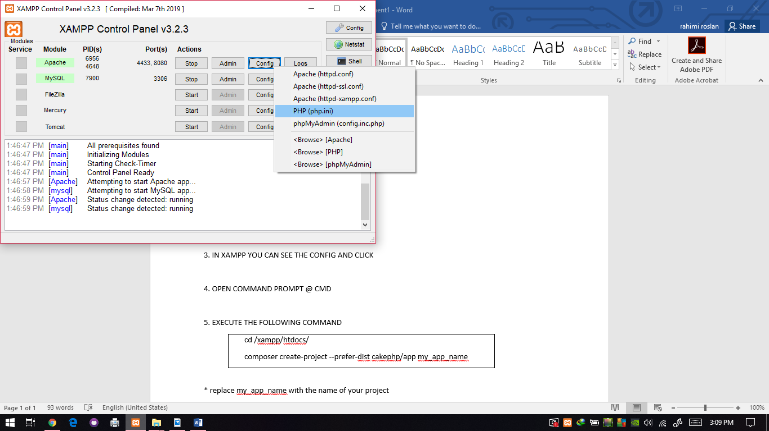

4. IN php.ini FIND ‘intl’ , REMOVE THE SEMICOLON (;) & SAVE THE FILE .

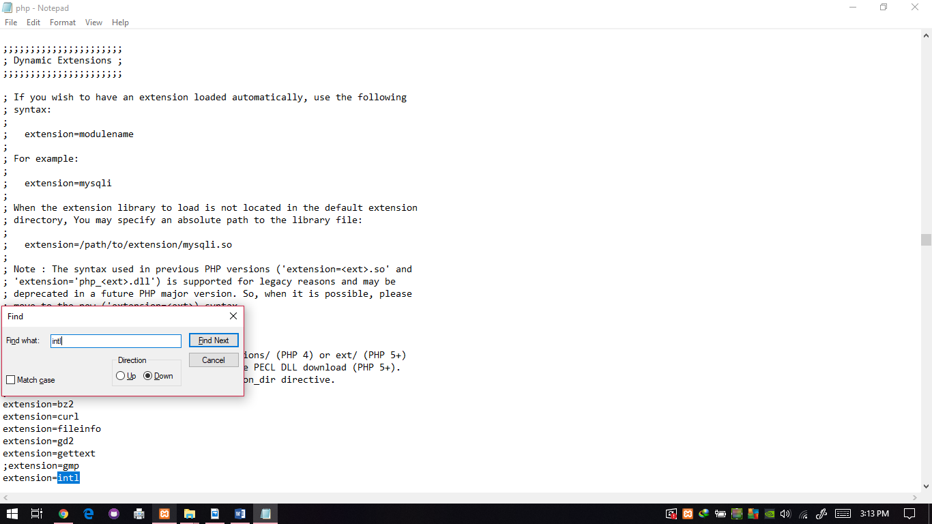

5. IN START, OPEN COMMAND PROMPT @ CMD & EXECUTE THE FOLLOWING COMMAND

|  |
| --- |
| cd /xampp/htdocs/  composer create-project --prefer-dist cakephp/app my_app_name |

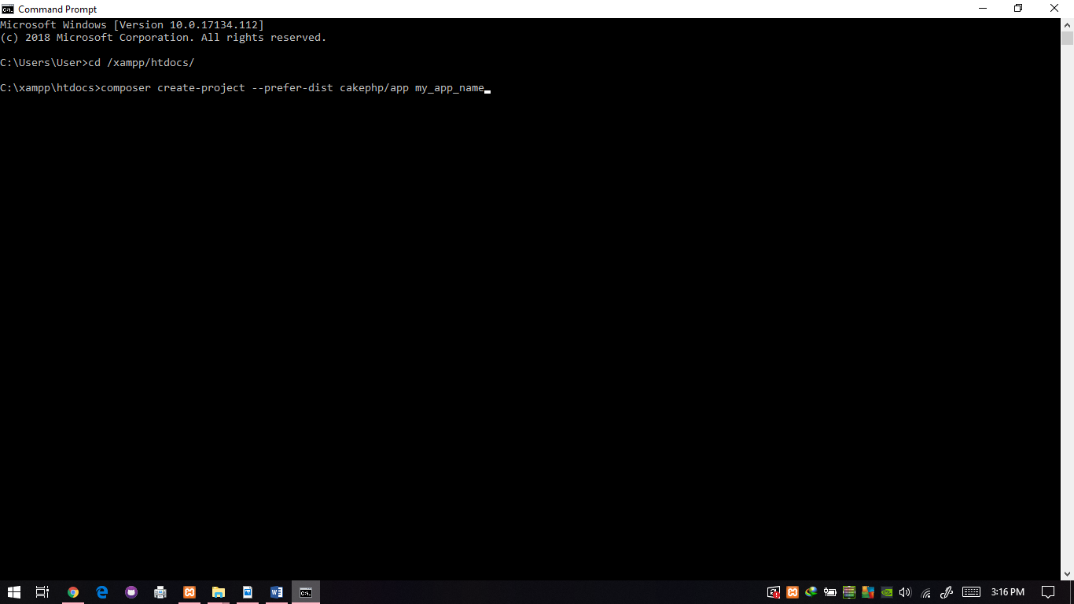

* replace my_app_name with the name of your project

** please make sure that you are already inside your web DocumentRoot folder before

running the above command

6. OPEN YOUR BROWSER & RUN ABOVE LINK

<http://localhost/phpmyadmin>

*this link to open the database

7. TO OPEN YOUR PROJECT, RUN ABOVE LINK

<http://localhost/my_app_name>

*must same with no. 4 name project

**you can see the database not connect

**CREATE DATABASE TO CONNECT WITH CAKEPHP**

1.CREATE A TABLE MANUAL OR

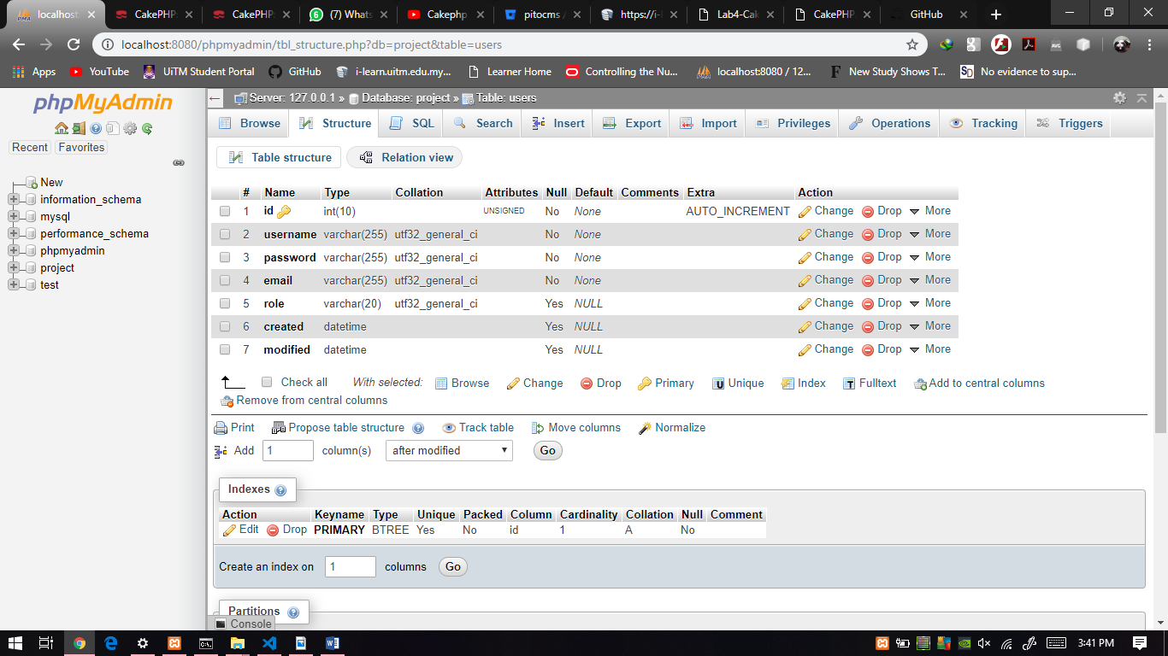

2.CREATE A TABLE WITH SQL COMMAND

|  |
| --- |
| CREATE TABLE users (  id INT(10) UNSIGNED NOT NULL AUTO_INCREMENT PRIMARY KEY,  username VARCHAR(255) NOT NULL,  password VARCHAR(255) NOT NULL,  email VARCHAR(255) NOT NULL,  role VARCHAR(20),  created DATETIME,  modified DATETIME  ) ENGINE=InnoDB DEFAULT CHARSET=utf32; |

3. OPEN THE PROJECT COMPOSER THAT YOU INSTALL LIKE NO. 4(HOW TO INSTALL CAKEPHP IN WINDOW) & CHOOSE THE app.php

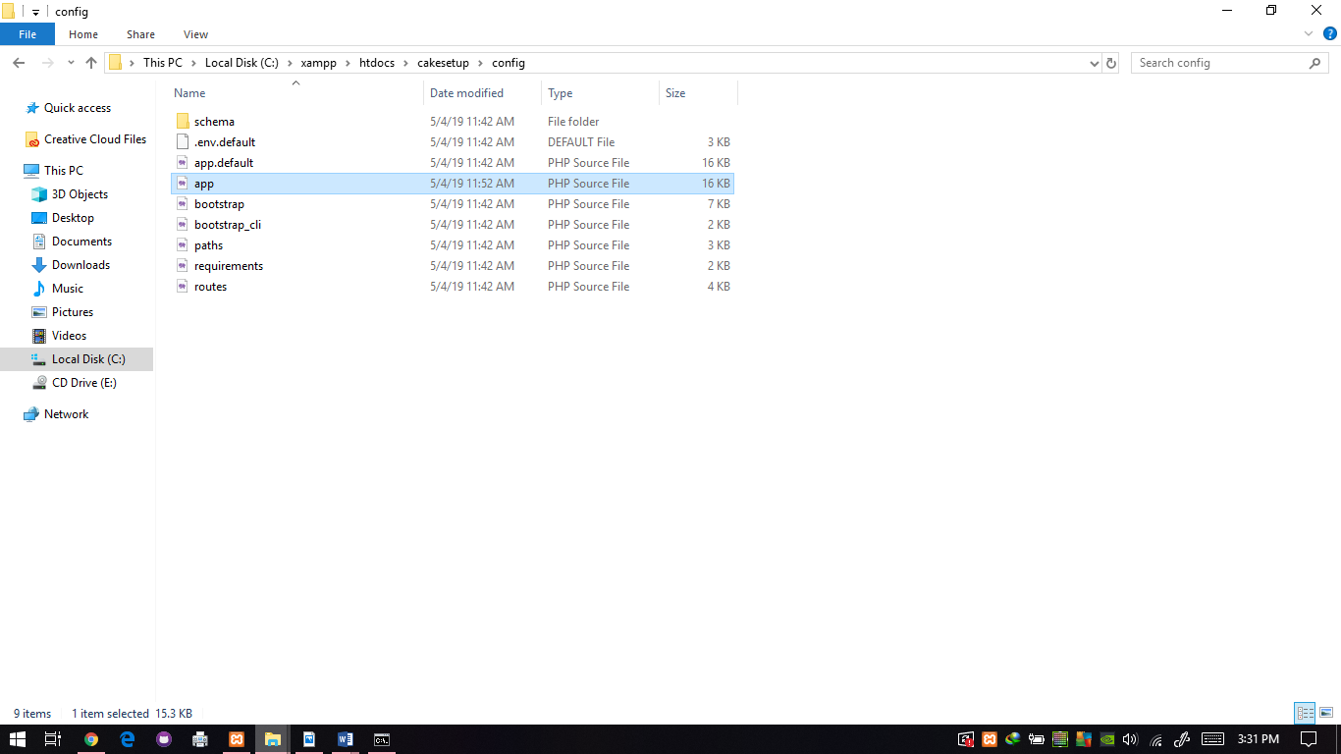

*I use the project name ‘cakesetup’

4. IN LINE 258, FOLLOW THIS ABOVE & SAVE FILE

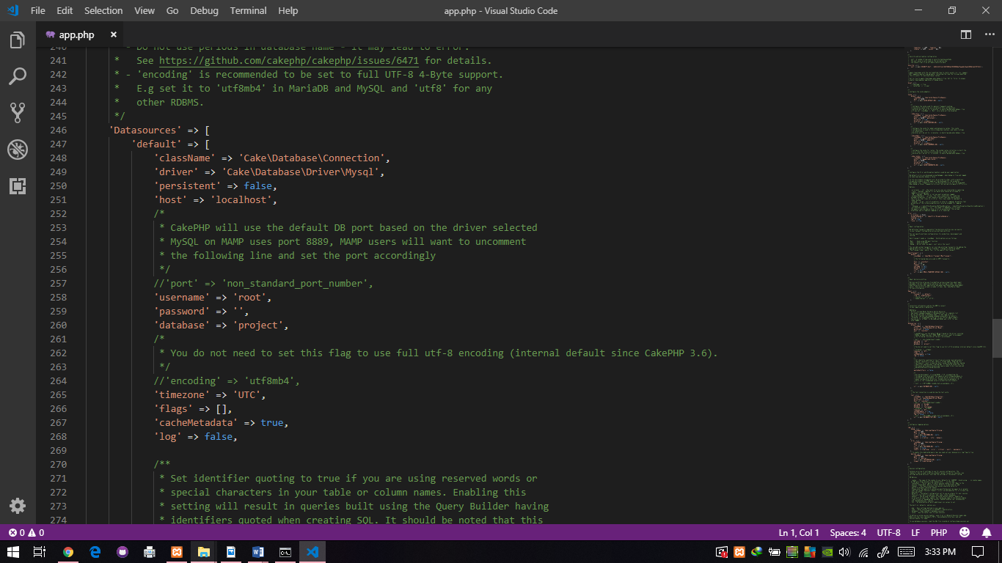

*in database, you key in your database name that you create in no. 1(CREATE DATABASE TO CONNECT WITH CAKEPHP)

5. OPEN YOUR BROWSER & RUN ABOVE LINK

<http://localhost/my_app_name>

*you can see your database was connected

**RUN YOUR CAKEPHP**

1.OPEN CMD & RUN COMMAND

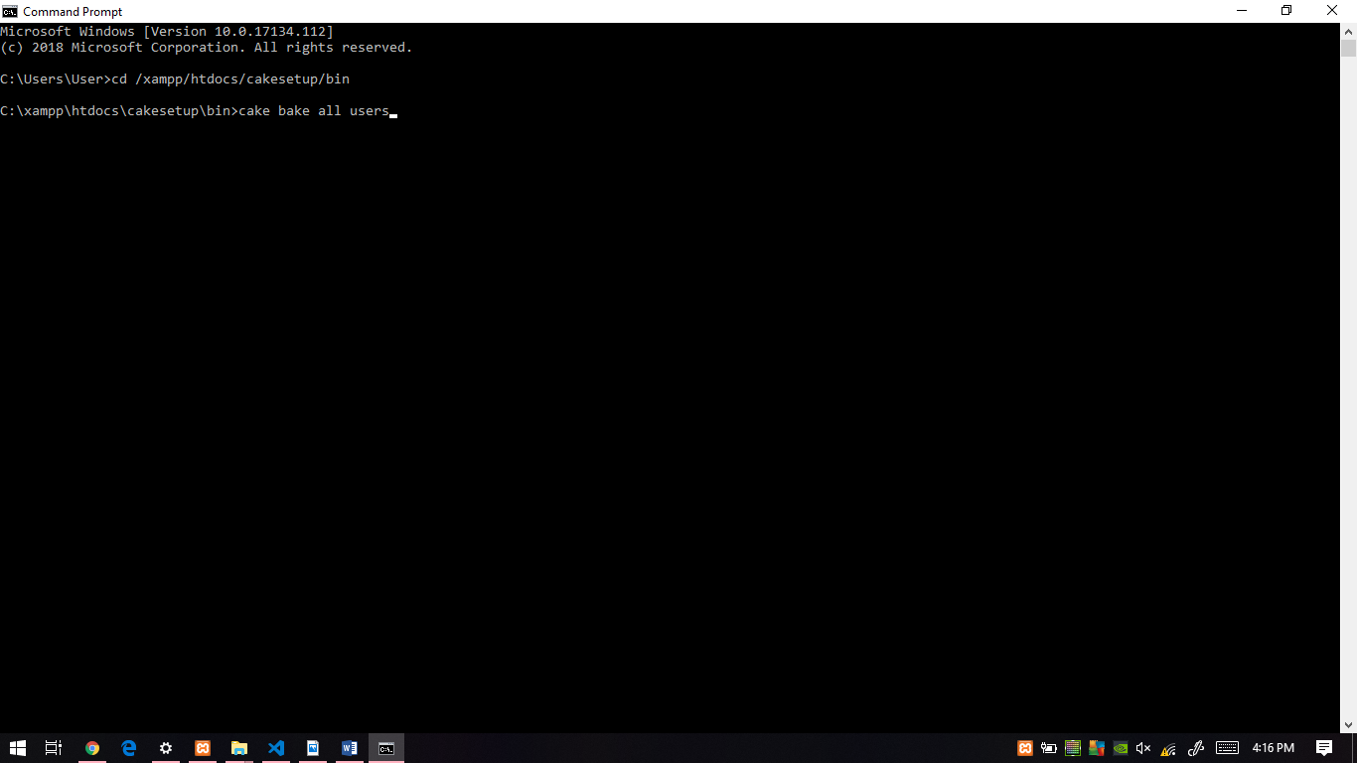 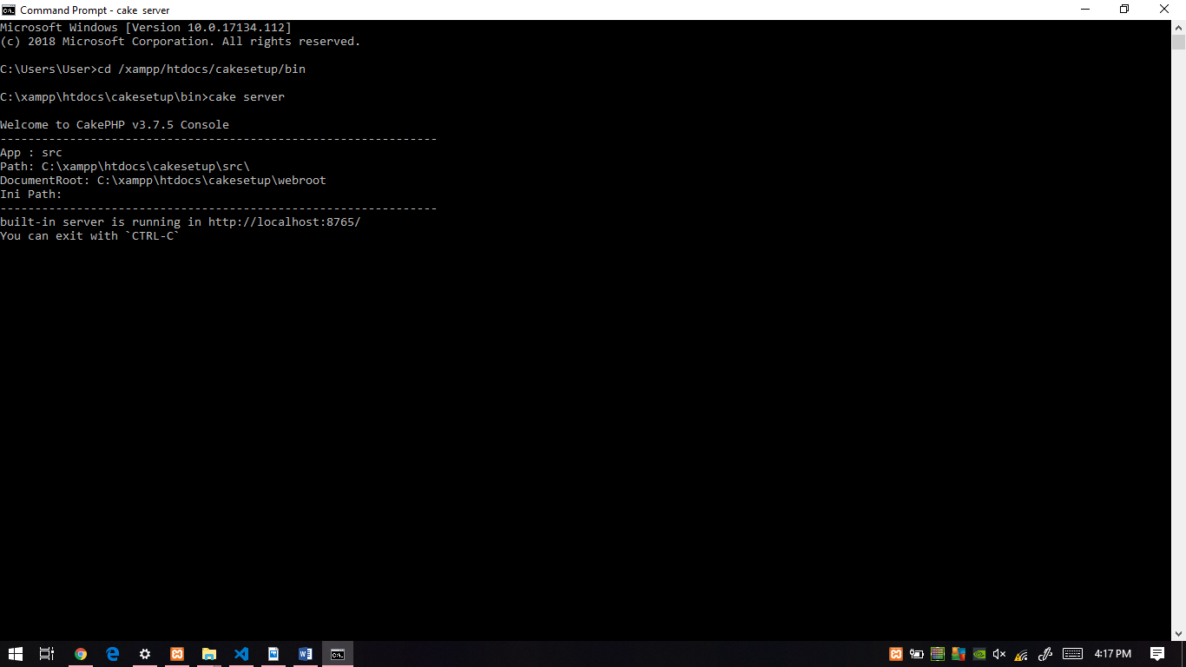

2.OPEN YOUR BROWSER & RUN LINK ABOVE

<http://localhost:8765/users>